Simulation 1) true alpha =50, true gamma = .5, 1, or 2, true Jmax= 50000

Fiting to simulated data using penalty on gamma only: log(gamma) ~N(log(1), sigma), sigma~exp(4). Went with exp(4) because more consistent convergence than exp(1).

Results

First column uses Chiwawa spawner data, second uses Nason spawner data, third column uses White spawner data. First row is gamma=0.5, second and third row is gamma = 1.0, fourth row is gamma = 2.0

*Alpha*

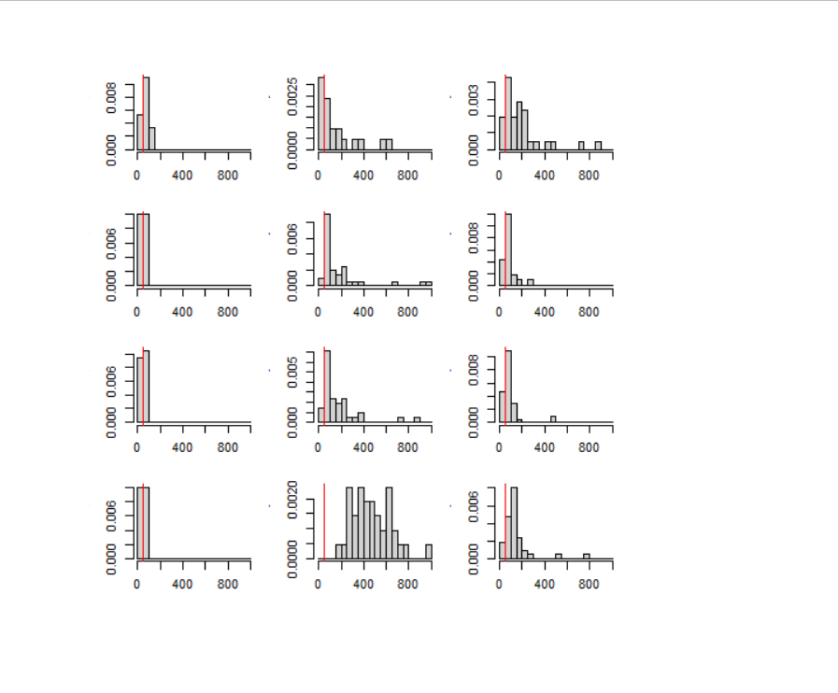

*Gamma*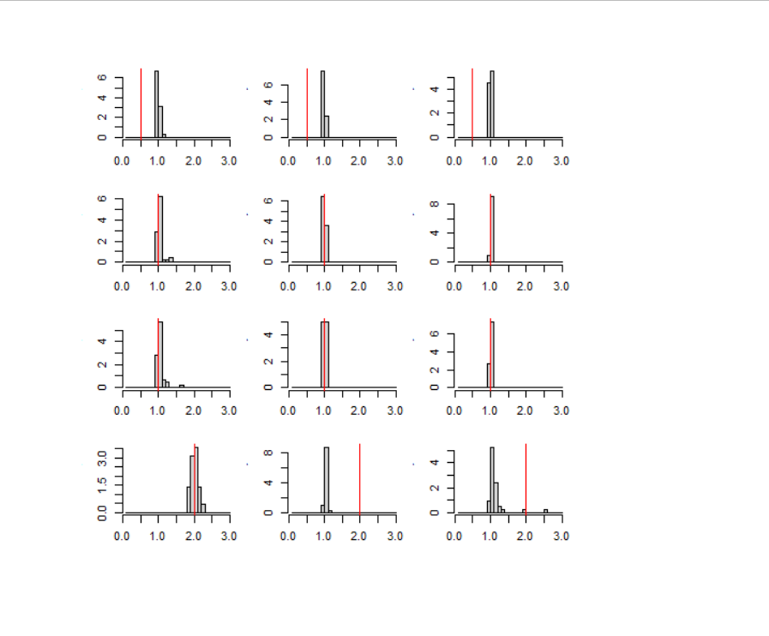

*Jmax*

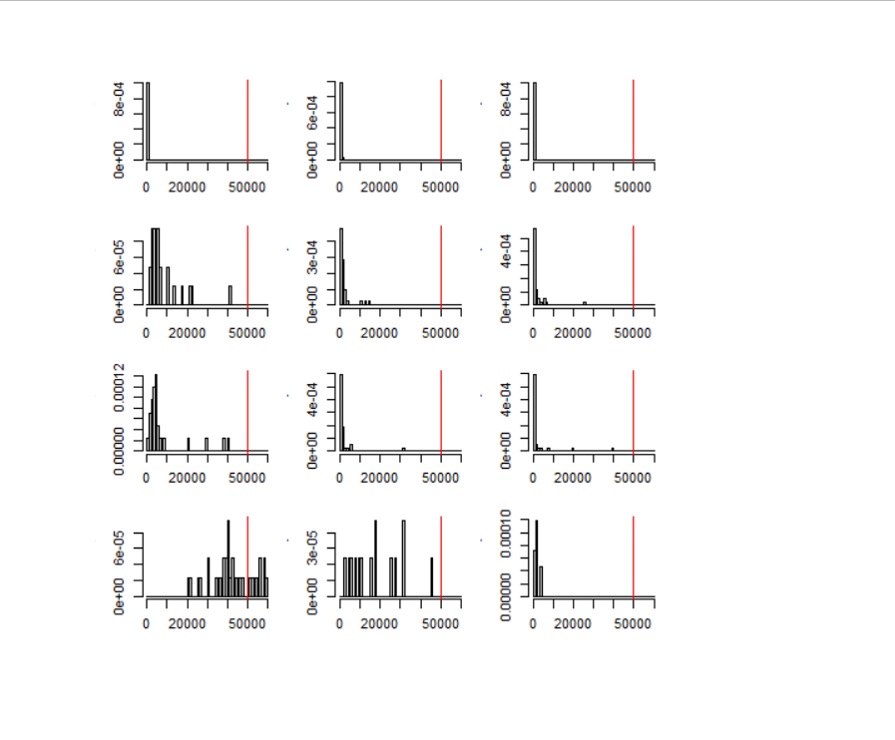

Conclusion: underestimating capacity substantially with no penalty on in it.

Simulation 2) same as above but in fit penalize Jmax in addition to gamma: log(Jmax) ~ N (log(50000), sigma), sigma ~ Exp(2). Same penalty on gamma as in simulation 1.

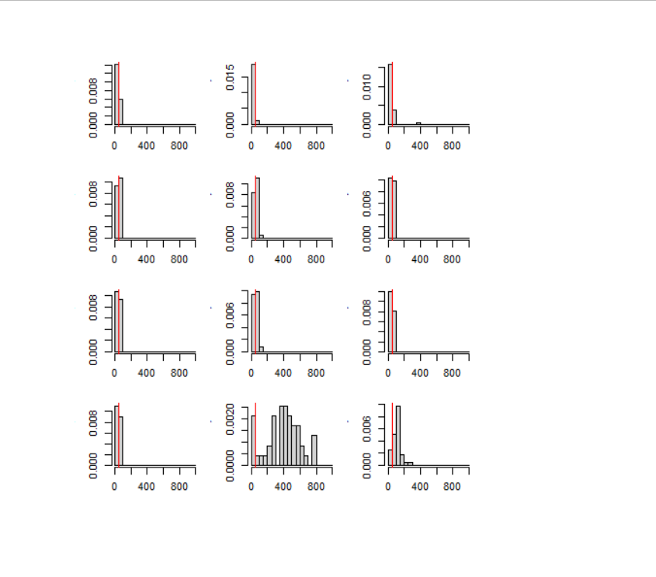

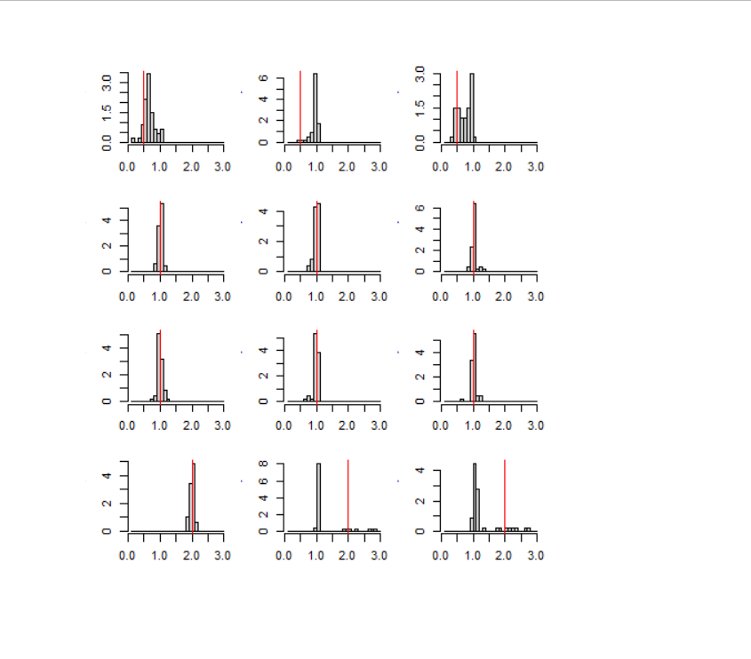

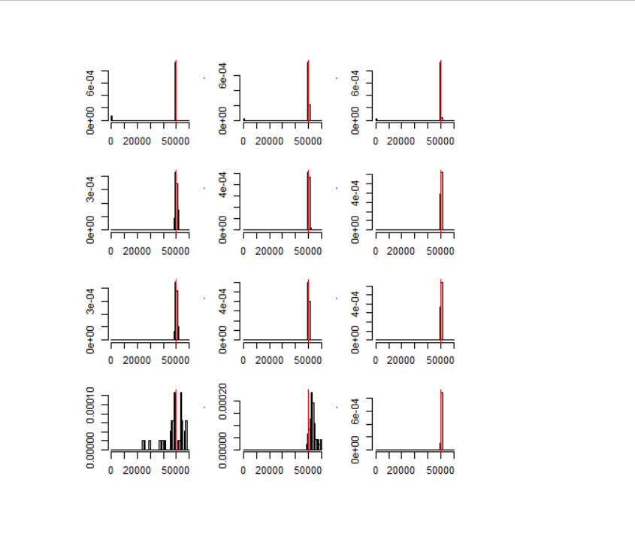

We do not have very much information to estimate the three parameters in this model for most of these stream x life history combinations, especially in Nason Creek and the White River where most years in the times series have had relatively few spawners. Therefore, we need to constrain the problem based on first principals and prior information. I propose to do this with penalties on the gamma and Jmax parameters. Gamma will be penalized as it deviates from 1.0, based on the prior assumption that there is neither positive nor negative density dependence and the expected number of juveniles of each life history increases linearly with increasing female spawner abundances, with the relationship determined by the alpha parameter. Jmax will be penalized as it deviates from a sufficiently large estimate of carrying capacity. This carrying capacity estimate can be based on the maximum female spawner density observed in the time series (approximately 40/kilometer), an approximate estimate of 4,500 eggs per female, a survival rate from egg to emigrants of 20%, and a maximum proportion of emigrants expressing any one life history of 50%. This results in a carrying capacity of 18,000 emigrants/kilometer of any single life history, which is more than twice the maximum number of juveniles of a single life history observed in any stream in one year. It is important to note, that negative density dependence can be modeled with gamma values <1.0 in addition to with Jmax, therefore, it is possible for models to have a very large Jmax but still exhibit density dependence even at low spawner abundance.